STATE MANDATES FOR HANDLING COVID-19 & COMPANY RESPONSE
To actively work to prevent the spread of this virus, to practice good citizenship, and to ultimately protect the safety of our patients and team members, for the foreseeable future <NAME OF COMPANY> will be offering only Emergency Dental Services which is at the discretion of the Doctors however below is guidance from the ADA as what constitutes a Dental Emergency.

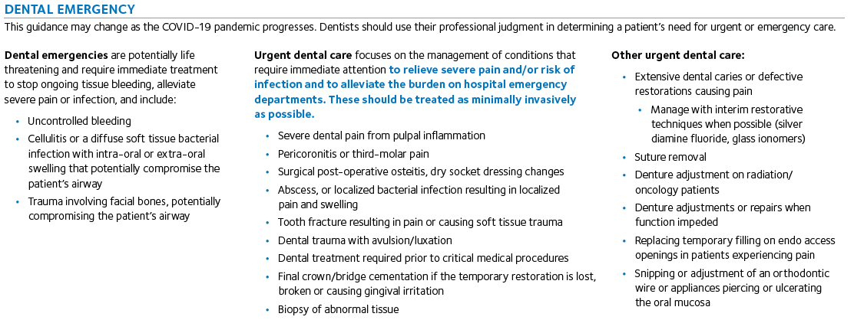

The idea is to limit the number of people in any given space. This is totally new territory for us all, so please work together with the Doctors and Practice Administrators to determine what is a dental emergency. It is imperative that we provide these only Dental Emergency services to the patients and communities we serve so that we do not burden the hospitals and urgent care facilities. We believe this guidance from the ADA will help practices accomplish this objective while ensuring the health and safety of dentists, their team members, and their patients.

Prohibited Dental Services are as follows;

- Initial or periodic oral examinations and recall visits, including routine radiographs,
- Routine dental cleaning and preventive therapies,
- Orthodontic procedures other than those to address acute issues (e.g. pain, infection, trauma),
- Extraction of asymptomatic teeth,
- Restorative dentistry including treatment of asymptomatic carious lesions,
- Aesthetic dental procedures.

The schedules through <INSERT DATE> will to be adjusted accordingly.

COVID-19 TEAM MEMBER WORK PLAN

Specific Plans for each office will be collaboratively developed and communicated with Doctor, Practice Administrator, RDO and COO.

- Hygiene Department: Reschedule all patients to <INSERT DATE> unless the Governor extends the order for Dental Emergencies only

- Restorative Patients: Treat all emergent and potentially urgent patients.

- Clinical:
      - Process all Lab Cases
      - Disinfect all ops
      - Clean, sterilize, re-organize lab, sterilization area
      - Wipe down all doors, door handles
      - Mop all floors
      - All rooms wiped down from top to bottom. Every unnecessary item that can be stored please do so. We want all hard surfaces cleaned. Start using your drawers and cabinets.
      - Maintenance of all equipment, change traps, clean autoclaves, sharpen instruments, oil handpieces, etc.
      - Ensure your OSHA manual is updated and protocols are followed.
      - Watch Open Dental and Solution Reach training videos.

- Operations:
  - For Exempt and non-furloughed hourly employees, work plans will be made for each working team member weekly. Team Hours:
      - No Over-Time Policy is in affect
      - Employees may only clock in 10 minutes prior to huddle
      - Employees must stop work at the scheduled time. Exceptions need to be reported by RDO every day.
      - Everyone should leverage cross training to the best of their ability (and pursuant to the law) during this time.

  - For Practice Administrators:
      - Confirming appointments for the next day. Patients deserve to hear a live voice and be ensured that we are all confident, healthy, ready to see them.
      - Every patient on the schedule will be contacted over the phone to explain the governor’s mandate and that rescheduling their appointment is “in their best interest.” “We are here, and your health is important to us!” Tell them we will call them back when we know when we will re-open to reschedule their non-emergent appointment.
      - After posting payments from insurance, we will still balance bill patients to continue cash flow for the office.
      - Work A/R – Develop a detailed work plan with Revenue Cycle (See Exhibit A) but in general:
        - Submit all outstanding claims. All aging claims from oldest to newest worked. Each claim must be called on. We do not care if the claim is “in progress.” It must still be called on to ensure timely payment. Insurance are holding out on their money too. We must increase our proactive behavior (please use this time to train others on your team to do your job if they are still working in the office with you).
        - Work all unresolved claims
        - Clean-up A/R
          - Credits,
          - Old balances
          - Determine which accounts are uncollectible
- Prepare Recall System
- Prioritize Unscheduled Tx Plans
- All admin areas wiped completely down – dust free- drawers organized, cabinets organized and labeled.
- Online CE to satisfy credential requirements.

Exhibit A

Patient A/R

- Pull an outstanding A/R report.
- Audit accounts individually to ensure balances are correct
  - Make necessary corrections/adjustments to ensure accounts are fully accurate
- Move account balances to correct patient – During conversions, payments were applied to the guarantors account which reflects inaccurate balances on family accounts linked to guarantors.

Due to the current situation and patient being laid off I am not certain what the legality is with collecting “old” balances however, we can still send statements monthly or as the account is audited to inform the patients about their balances. Even if we only receive 5 payments from 20 of the statements its more than we will receive if we don’t send/communicate balances. We can discuss this further regarding how you prefer to move forward with notifying patient of existing balances so that we are being sympathetic with the COVID-19 situation.

Insurance A/R

- Pull outstanding Insurance A/R report to include all open/non-paid claims
- Work claims (Oldest to most current) starting with oldest claims first
  - We can break the report by insurance carrier as well to decrease our hold times.
  - Some ins carriers will only work 5-10 claims on each phone call but we should follow up on as many as we can by placing 1 phone call. Working multiple claims on 1 call with decrease the hold times and increase our productivity.
- Submit all necessary documentation and track denials
  - Tracking denials should show us history on how the office is submit claims and what attachments are being sent and what attachments should be sent with each procedure code to ensure claims are paid on 1st submission rather than 2nd-3rd attempts.

